

Conference Report

**Monday 11th March 2024**

**Riverside Stadium**

**Middlesbrough**

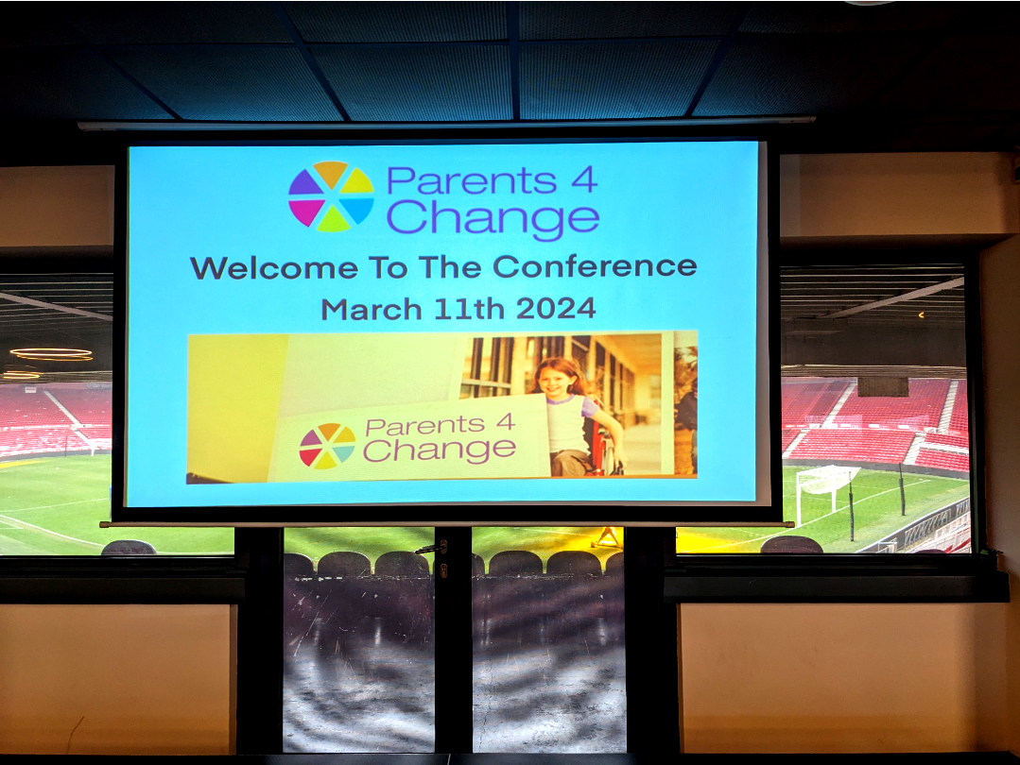

# Introduction

# Parents 4 Change is organised by a group of Middlesbrough parents and carers of children with disabilities.

# They are committed to ensuring that parents and carers of children and young people with disabilities and special educational needs are involved as equal partners in decision making with local education, social care, health and voluntary agencies.

**For many years they have been running conferences to bring together families and professionals to talk about support and services for children with disabilities in Middlesbrough.**

**People enjoyed this conference and some good feedback was received.**

**Usually parents talk about their lives and the support they receive, but this time all the presentations were from professionals talking about changes and developments.**

**One parent said “everything is very grim at the moment so parents are not able to bring the good news stories they usually bring”.**

**Another said “how did they get such a good Ofsted report when we are feeling so bad?”**

**In difficult times it is important that families and professionals can work in partnership to listen to each other and share views.**

**If you would like to find out more about Parents4Change you can find them on Facebook - or you can contact them at:**

**Email: info@parents4change.co.uk**

# Contents

1. **Opening and Welcome - Ruth Johnson**

**Conference Chair**

1. **Chris Cooke - Middlesbrough Mayor**
2. **Clive Heaphy - Chief Executive Officer**
3. **Update from Children with Disabilities Team**

**- Lauren Elliott**

1. **Transport - Helen Harris**

**Beverley School Choir**

1. **SEND update - Caroline Cannon - Middlesbrough Council**
2. **Supported Internships Kate Newton**
3. **Dynamic Support Register - Mark Porter**
4. **Sendiass Service - Sarah Duncan**
5. **Daisy Chain - Laura Callender**
6. **Update from Adult services**
7. **Closing Remarks - Ruth Johnson**

**Appendix 1 Summary of Feedback**

1. **Opening and Welcome**

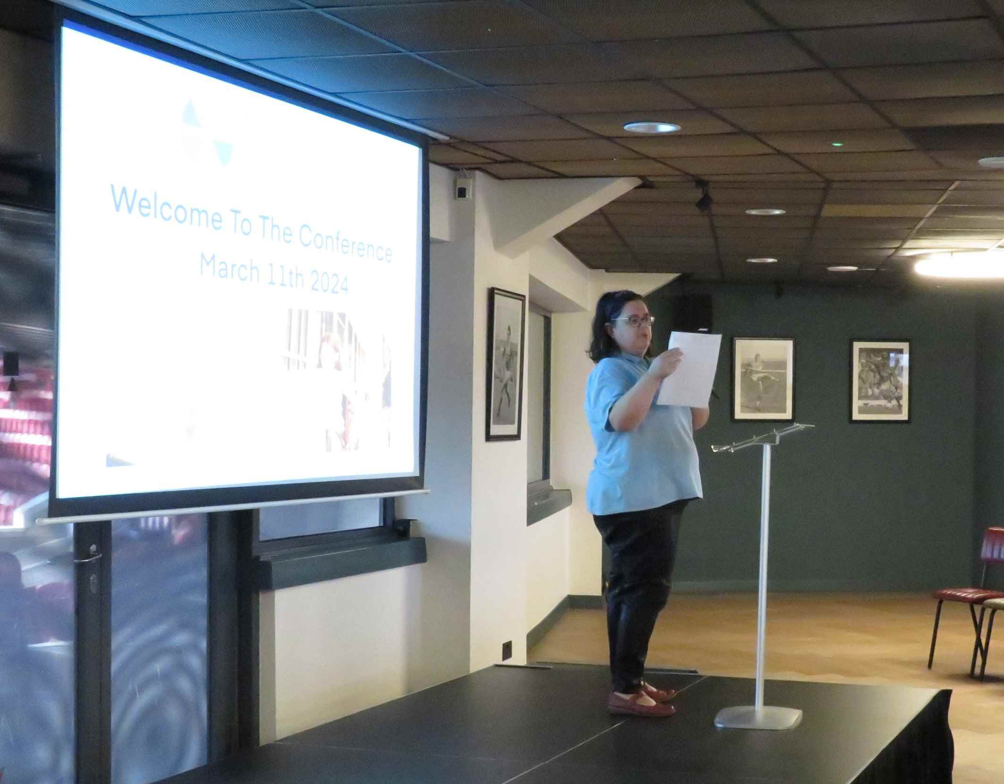

**Ruth Johnson**

**Conference Chair**

Ruth thanked everyone for coming to the conference and went through “housekeeping arrangements”. She explained that information stands were available for people to look at during the morning break and at lunch.

Ruth introduced the Mayor and welcomed him to the conference.

1. **Chris Cooke - Middlesbrough Mayor**

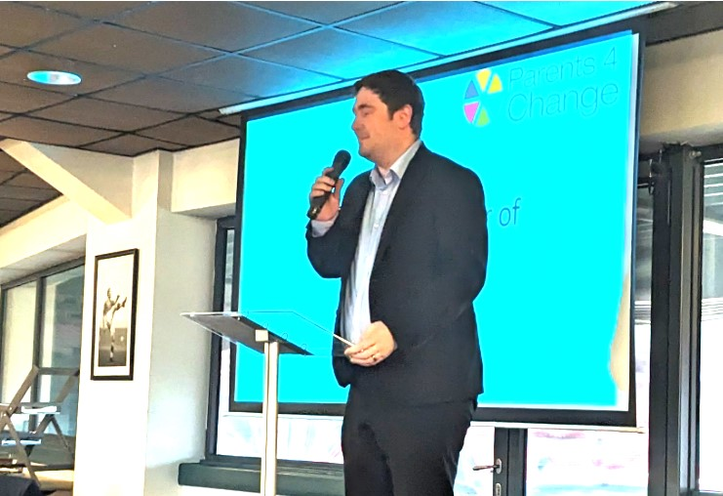

Chris said that it was

good to be at the

conference.

He said he had

grown up in care and

many of his foster

siblings had disabilities

and this had helped his

understanding.

Chris said “peer to peer” support was very important and so he was greatful to those who organised the conference.

He said now the budget was passed progress could be made towards helping people in a “proper dignified way”.

Chris continued that there would be movement from supporting people in buildings to supporting them in the community. He said there had not been many meetings between Parents4Change and the Council, but those would be starting again soon.

1. **Clive Heaphy - Chief Executive Officer**

It was expected that Chief Executive would attend at this point and parents had hoped that he would talk about the budget/support for children with disabilities, but they received a message at the beginning of the conference to say he could not attend.

1. **Update from Children with Disabilities Team**

**- Lauren Elliott**

Lauren described herself as the Designated Social Care Officer working across SEND and the Children with Disabilities Service. She said the quality of social care advice to the Education Health and Care Plan (EHCP) was much improved.

She explained new criteria had been put in place in 2022 and most people who have a child with a disability would not need a social worker. She used the diagram below to illustrate that there was support from other services available.

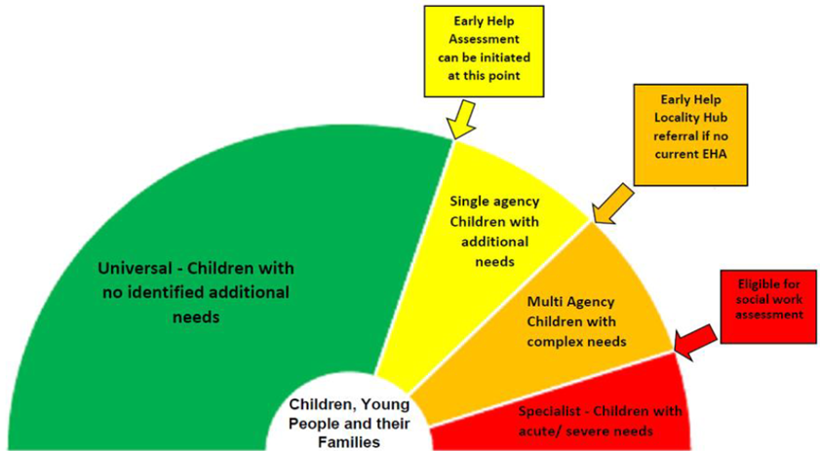

Lauren said that the Multi-Agency Children’s Hub (MACH)

Could be contacted by anyone who needed support and wanted to make a referral:

The details are:

Telephone: 01642 726004

[middlesbroughMACH@middlesbrough.gov.uk](mailto:middlesbroughMACH@middlesbrough.gov.uk)

A referral to MACH will be screened by social workers using the CWD eligibility criteria to ensure consistent decision making - the outcome might be:

* CWD social work teams for assessment
* Occupational Therapy team for OT assessment
* Short breaks team for assessment
* Stronger families support (where threshold isn’t met but there is a need at level 3)
* Assessment teams (where threshold isn’t met but there is a need at level 4)
* Level 2 service recommendations (Local offer, schools, Daisy Chain etc)
* Information, advice and signposting with no further action from social care

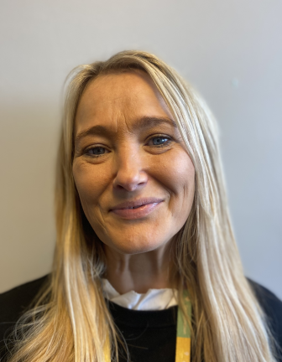

1. **Transport**

* **Helen Harris**
* **Kirsty McCann**

Helen explained that she is

from the Integrated Transport

Unit and in some cases they can

offer some pupils and adults travel assistance between home and school. She said the staff structure has grown rapidly over the past few months, to accommodate the growing numbers of children and adults needing help with transport.

They have recruited several new staff recently and this would help dealing with cancellations etc. They have also just recruited a new travel trainer.

If a family are unable to assist with travel to and from school, then the SEN worker can discuss Travel Assistance with them.

Helen said the service can offer a “hierarchy of help” which includes:

* Route Planning
* Travel Training
* Refund of Bus Fares
* Parental Travel allowance
* Transport from a designated pick-up point
* Transport Home to School

It was explained that where a family choose a school which the Local Authority does not think meets the child’s needs, then parents would have to pay for transport.

The Home to School transport policy for Middlesbrough Council is freely available on the below website:

[https://www.middlesbrough.gov.uk/schools-and-education/home-to-school-transport/ Council](https://www.middlesbrough.gov.uk/schools-and-education/home-to-school-transport/)

The policy is reviewed and updated every academic year.

Kirsty said the service recognises that communication has been poor, and with a new team in place they are working on a communication plan with actions on improving communication between the office and parents/carers.

She provided the following email address for comments/questions:

[transport@middlesbrough.gov.uk](mailto:transport@middlesbrough.gov.uk)

**Beverley School Choir**

After a coffee break there was a wonderful performance by the Beverley School Choir

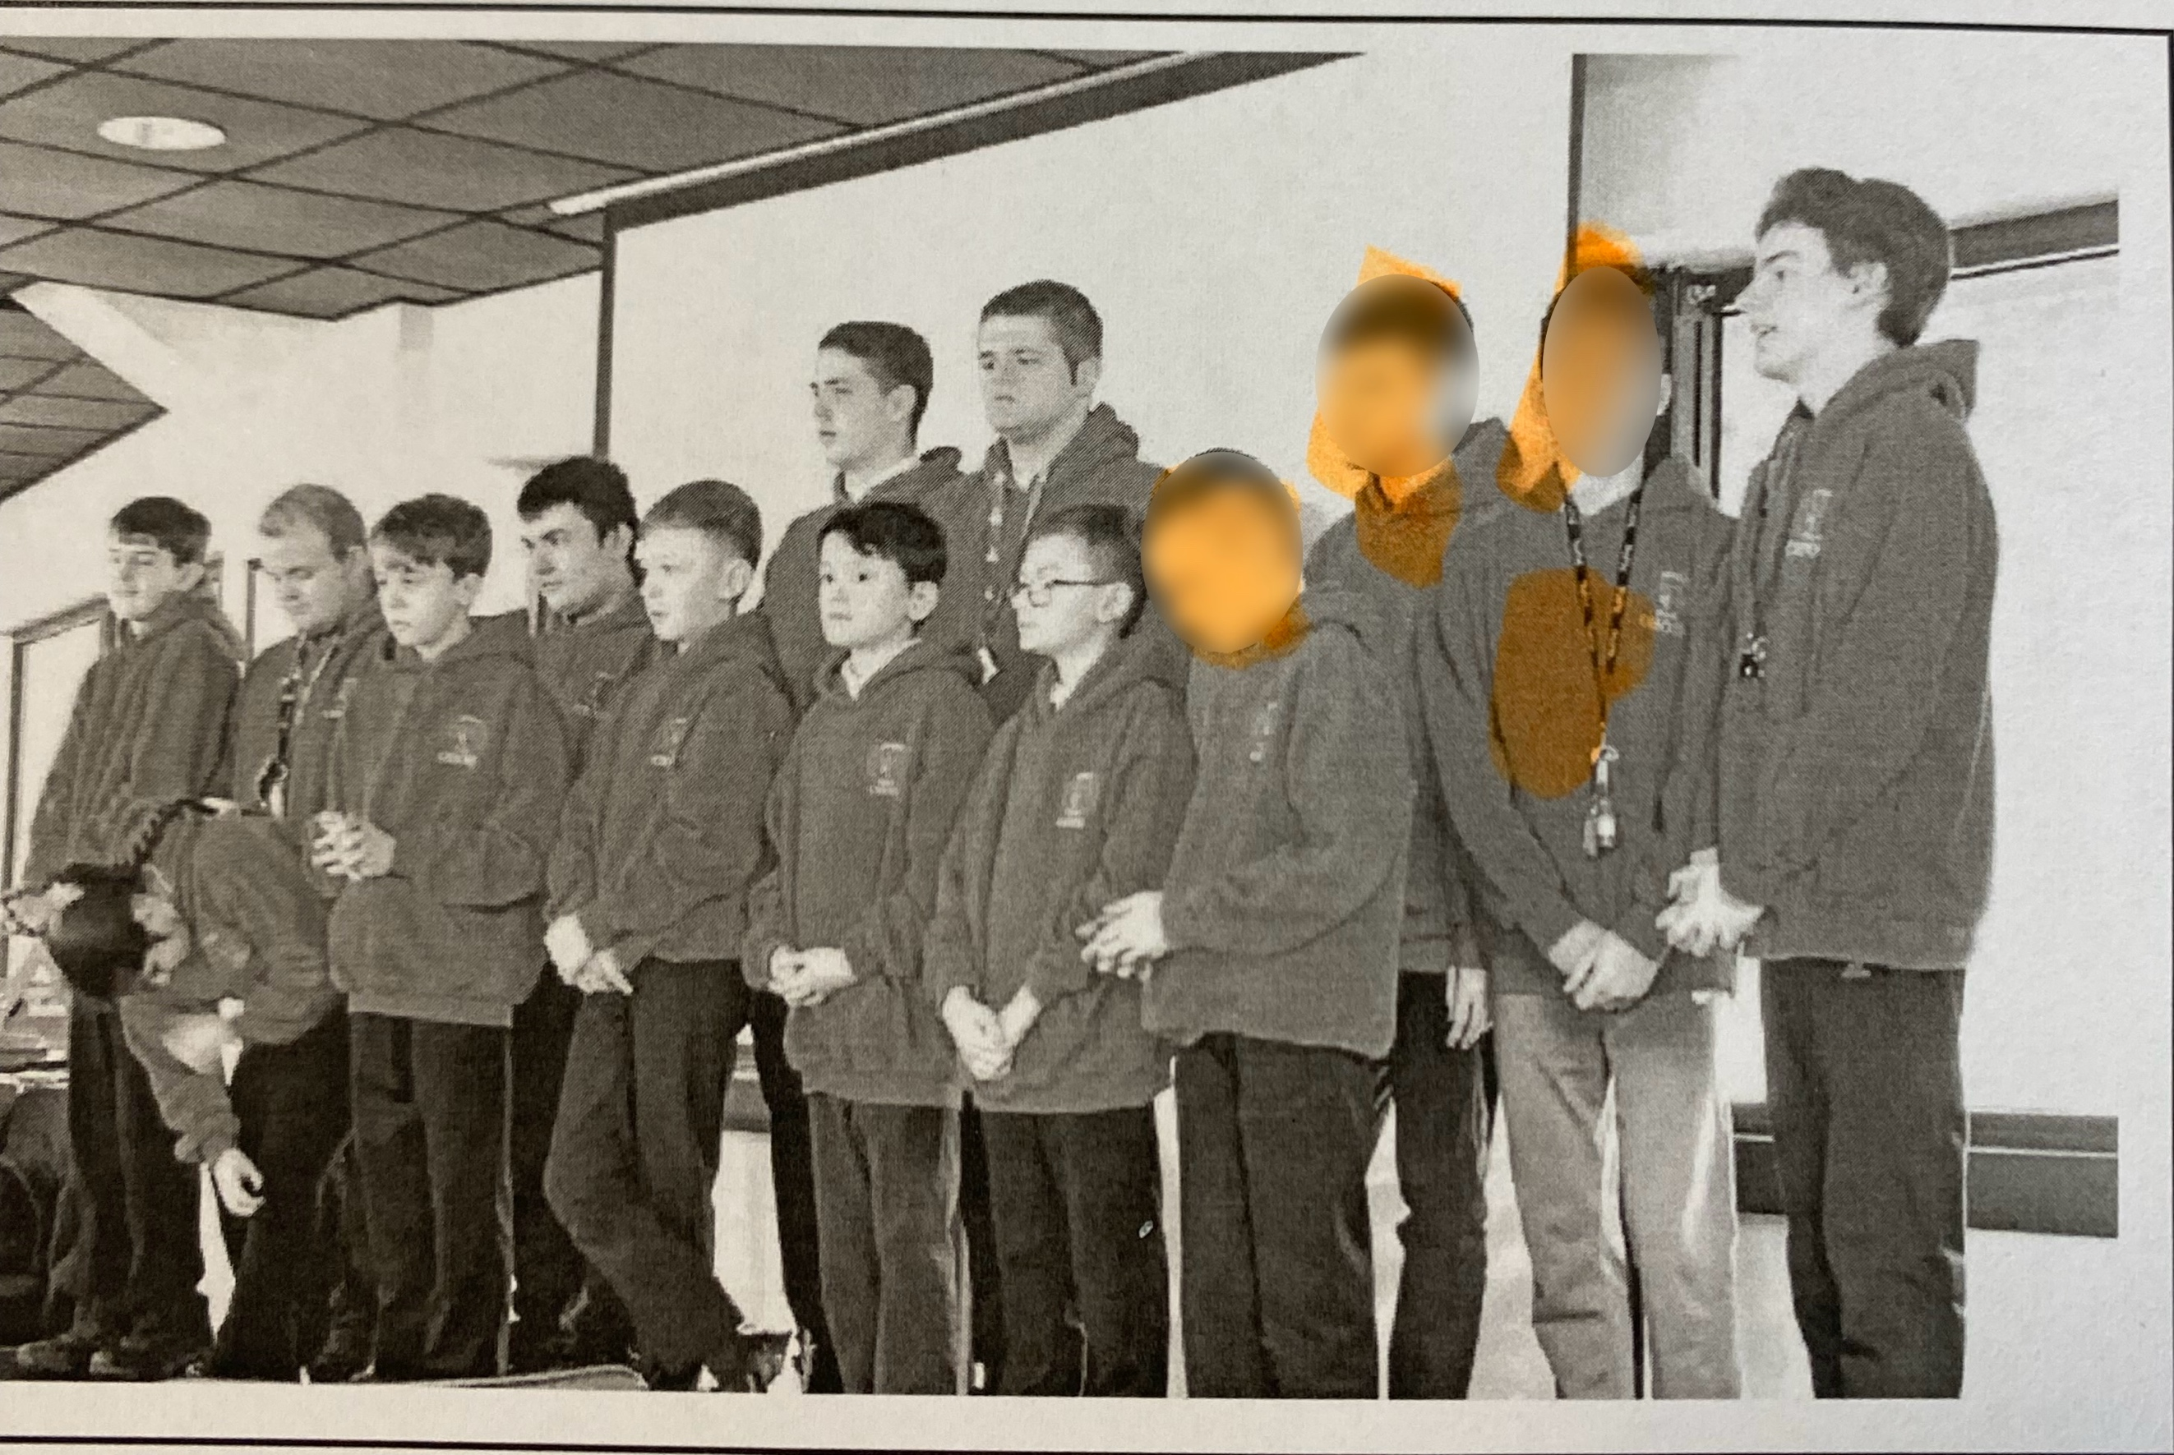

They sang a number of songs including:

* Only You
* Day Dream Believer
* I have a Dream

Everybody enjoyed the performance.

1. **SEND update - Caroline Cannon - Middlesbrough Council**

Caroline talked about the Inclusion and support service which includes:



* Assessment and Review Service
* Inclusion and Outreach Service
* Cleveland Unit
* Education Psychology
* Shared Hearing Impaired

and Visual Impaired Service

* Local Offer
* Resources

Caroline referred to many achievements made in the local area - she said the service had:

* Increased the number of specialist provision across the local area
* Increased the number of registered Alternative Provision
* Coproduced and updated our SEND and Inclusion strategies in partnership with families
* Developed the Neurodevelopment Pathway
* Developed training offer for parents and carers
* Increased the range of Post 16 Opportunities
* Developed a coproduction charter in partnership with our families
* Reshaped services to meet needs
* Ensured a range of training and support is in place to support staff to meet the needs of children and young people with SEND and those accessing Alternative Provision
* Further developed our data systems to ensure we are responsive to changing needs
* Continue to monitor closely the impact of COVID on our children and young people and identify solutions to meet needs

Caroline also talked about the recent three week SEND inspection by OFSTED which had looked at services across Education Health and Social Care in Middlesbrough. The highest possible grade had been achieved. Caroline explained there are many challenges in Middlesbrough as:

* The number of EHCP plans is larger than the National average
* There are a high number of suspensions and exclusions
* There is an increasing number of requests for EHCA since Covid



1. **Supported Internships Kate Newton**

Kate explained she was from Choices College and based at My Place.

Supported Internships are an education study programme for young people with learning disabilities aged 16 to 24 with an Education Health & Care Plan (EHCP) who want to move into employment and need extra support to do so.

The aim is to support young people to be as independent as they can be - being able to work helps with:

* Financial independence
* Self esteem
* Social opportunities

Kate said 50% of their students are able to move to paid or voluntary roles.

Kate described two young people who had benefitted from the training:

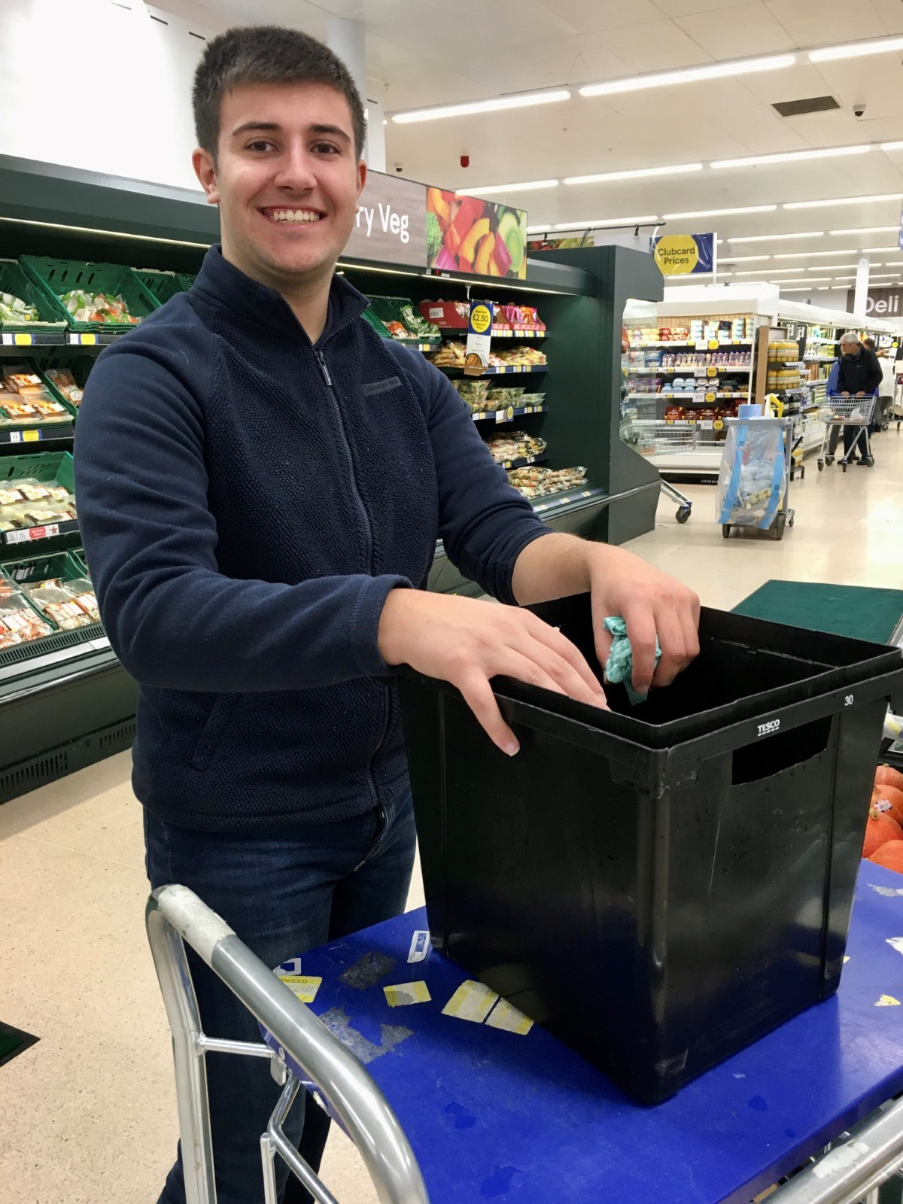

**Louis** has a diagnosis of Autism

Spectrum Disorder (ASD)

and Attention Deficit Hyperactivity

Disorder (ADHD).

When he joined Choices College in

2022 he was struggling with working

memory and struggled maintaining

concentration levels when distractions

were around him.

With help and support Louis has now been able to get a paid job at

Tesco where he is very happy.

**Sean** required support in placement with reassurance, guidance, understanding boundaries in a work environment, ensuring he managed his timekeeping and support in appropriately communicating with his work colleagues.

Staff worked closely with Sean over the year to draw out his skills and identify where he could showcase them. His second placement of the academic year was at MKM Building Supplies.

Sean said:

*“I liked my work placement at MKM.*

*I am always on time and like everyone.*

*I am really happy I have been offered a job,*

*I will stay here for at least 30 years.”*

Kate said:

* Choices College is a bespoke college within the NHS providing supported internships operates 5 days a week, Monday to Friday over an academic year, September to July,
* Placements with Choices College business partners are bespoke and related to each Interns skills and interests.
* Throughout the year, each week Interns attend 1 full day of education (maths, english and employability lessons) and up to 4 days of professional placements.
* Local Coordinators complete weekly/ fortnightly reviews and work with partners to develop and maintain the Intern placements.
* Person-centred, outcome focused, quality driven and based on excellence.
* Funded by the ESFA & commissioning Local Authority

Kate is Area Manager for Middlesbrough, Redcar & Cleveland and her contact details are:

[Kate.newton12@nhs.net](mailto:annette.lafitte@nhs.net)

1. **Dynamic Support Register - Mark Porter**

Mark is employed by the NHS and is the Designated Clinical Officer (SEND)

He talked about the Children’s Dynamic Support Register - the overall aim is to identify children and young with a learning disability, mental health problem or autism and who are at risk of having to be admitted to hospital. The intention is to review their needs and make sure the right support is in place in the community.

Mark explained:

* The purpose of the DSR is to ensure that an integrated approach between health, social care and education is in place across Tees Valley, for the risk management of children and young people (CYP) with learning disabilities, autism or other mental health issues.
* The overall purpose of the group is to ensure robust care packages are in place for hospital discharge, minimise the need for hospital admission, reduce health inequalities and improve outcomes for CYP with learning disabilities, autism or other mental health issues.
* The group brings together professionals with responsibility for commissioning, procuring and delivering services to individuals who are at risk of admission or who are inpatients in specialist hospitals.

The DSR group meets monthly bringing together representatives from Health, Education, Social Care and Daisy Chain across Middlesbrough, Hartlepool, Darlington, Redcar and Stockton.

Professionals can make referrals to this group, but it will also accept referrals directly from families - or from young people themselves. For people who are over 16 with capacity they need to provide consent themselves. For people who are under 16 parental consent can be given. . (Details concerning how to make a referral can be found on the “Local Offer”)

Mark Porter by email  - [**nencicb-tv.childrensdsr@nhs.net**](mailto:nencicb-tv.childrensdsr@nhs.net)

Mark’ presentation was followed by an excellent **lunch break** - people were provided with a great selection of food.

There was also time for people to talk to each other and look at the information stands available.

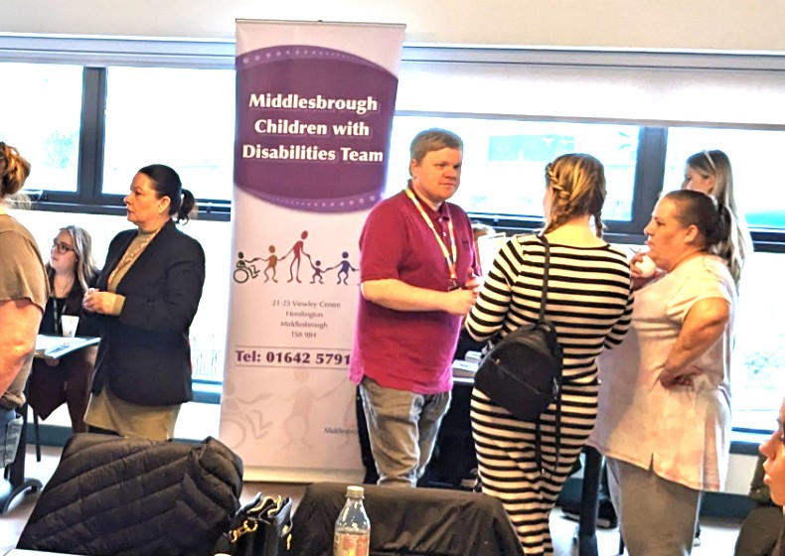

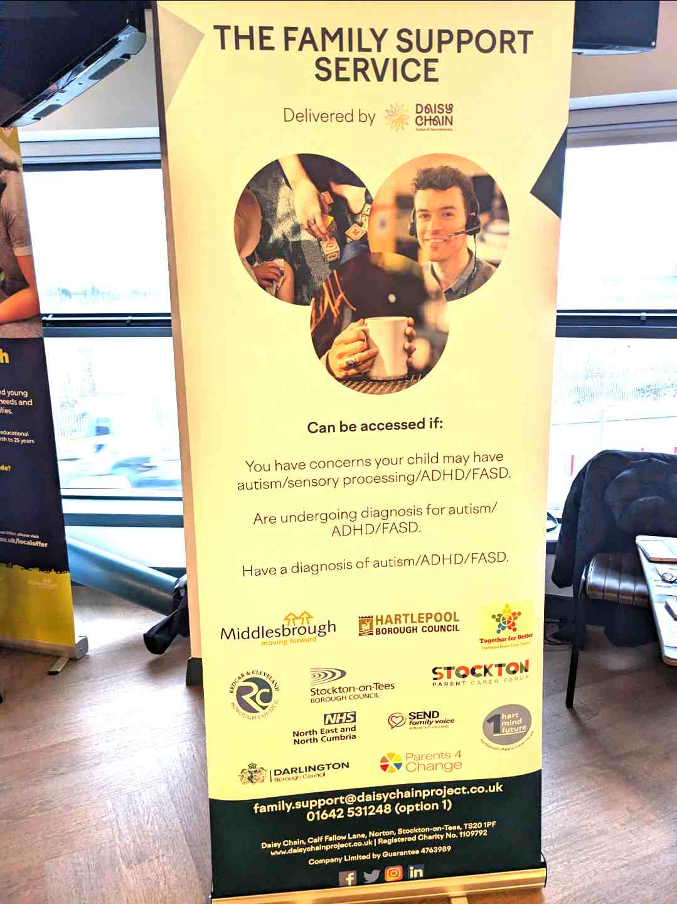

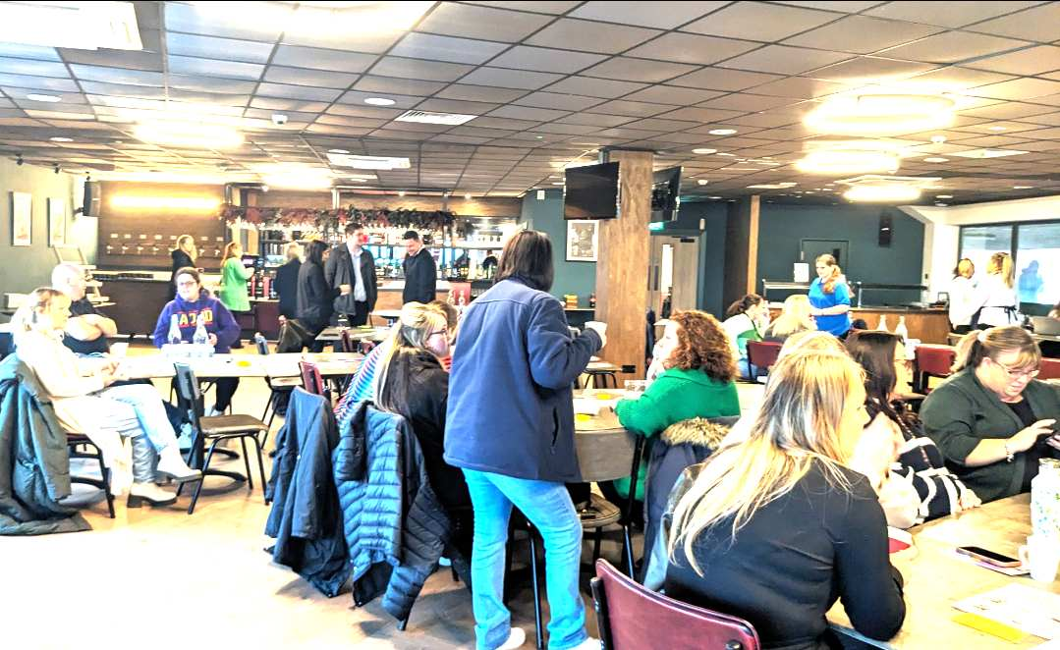

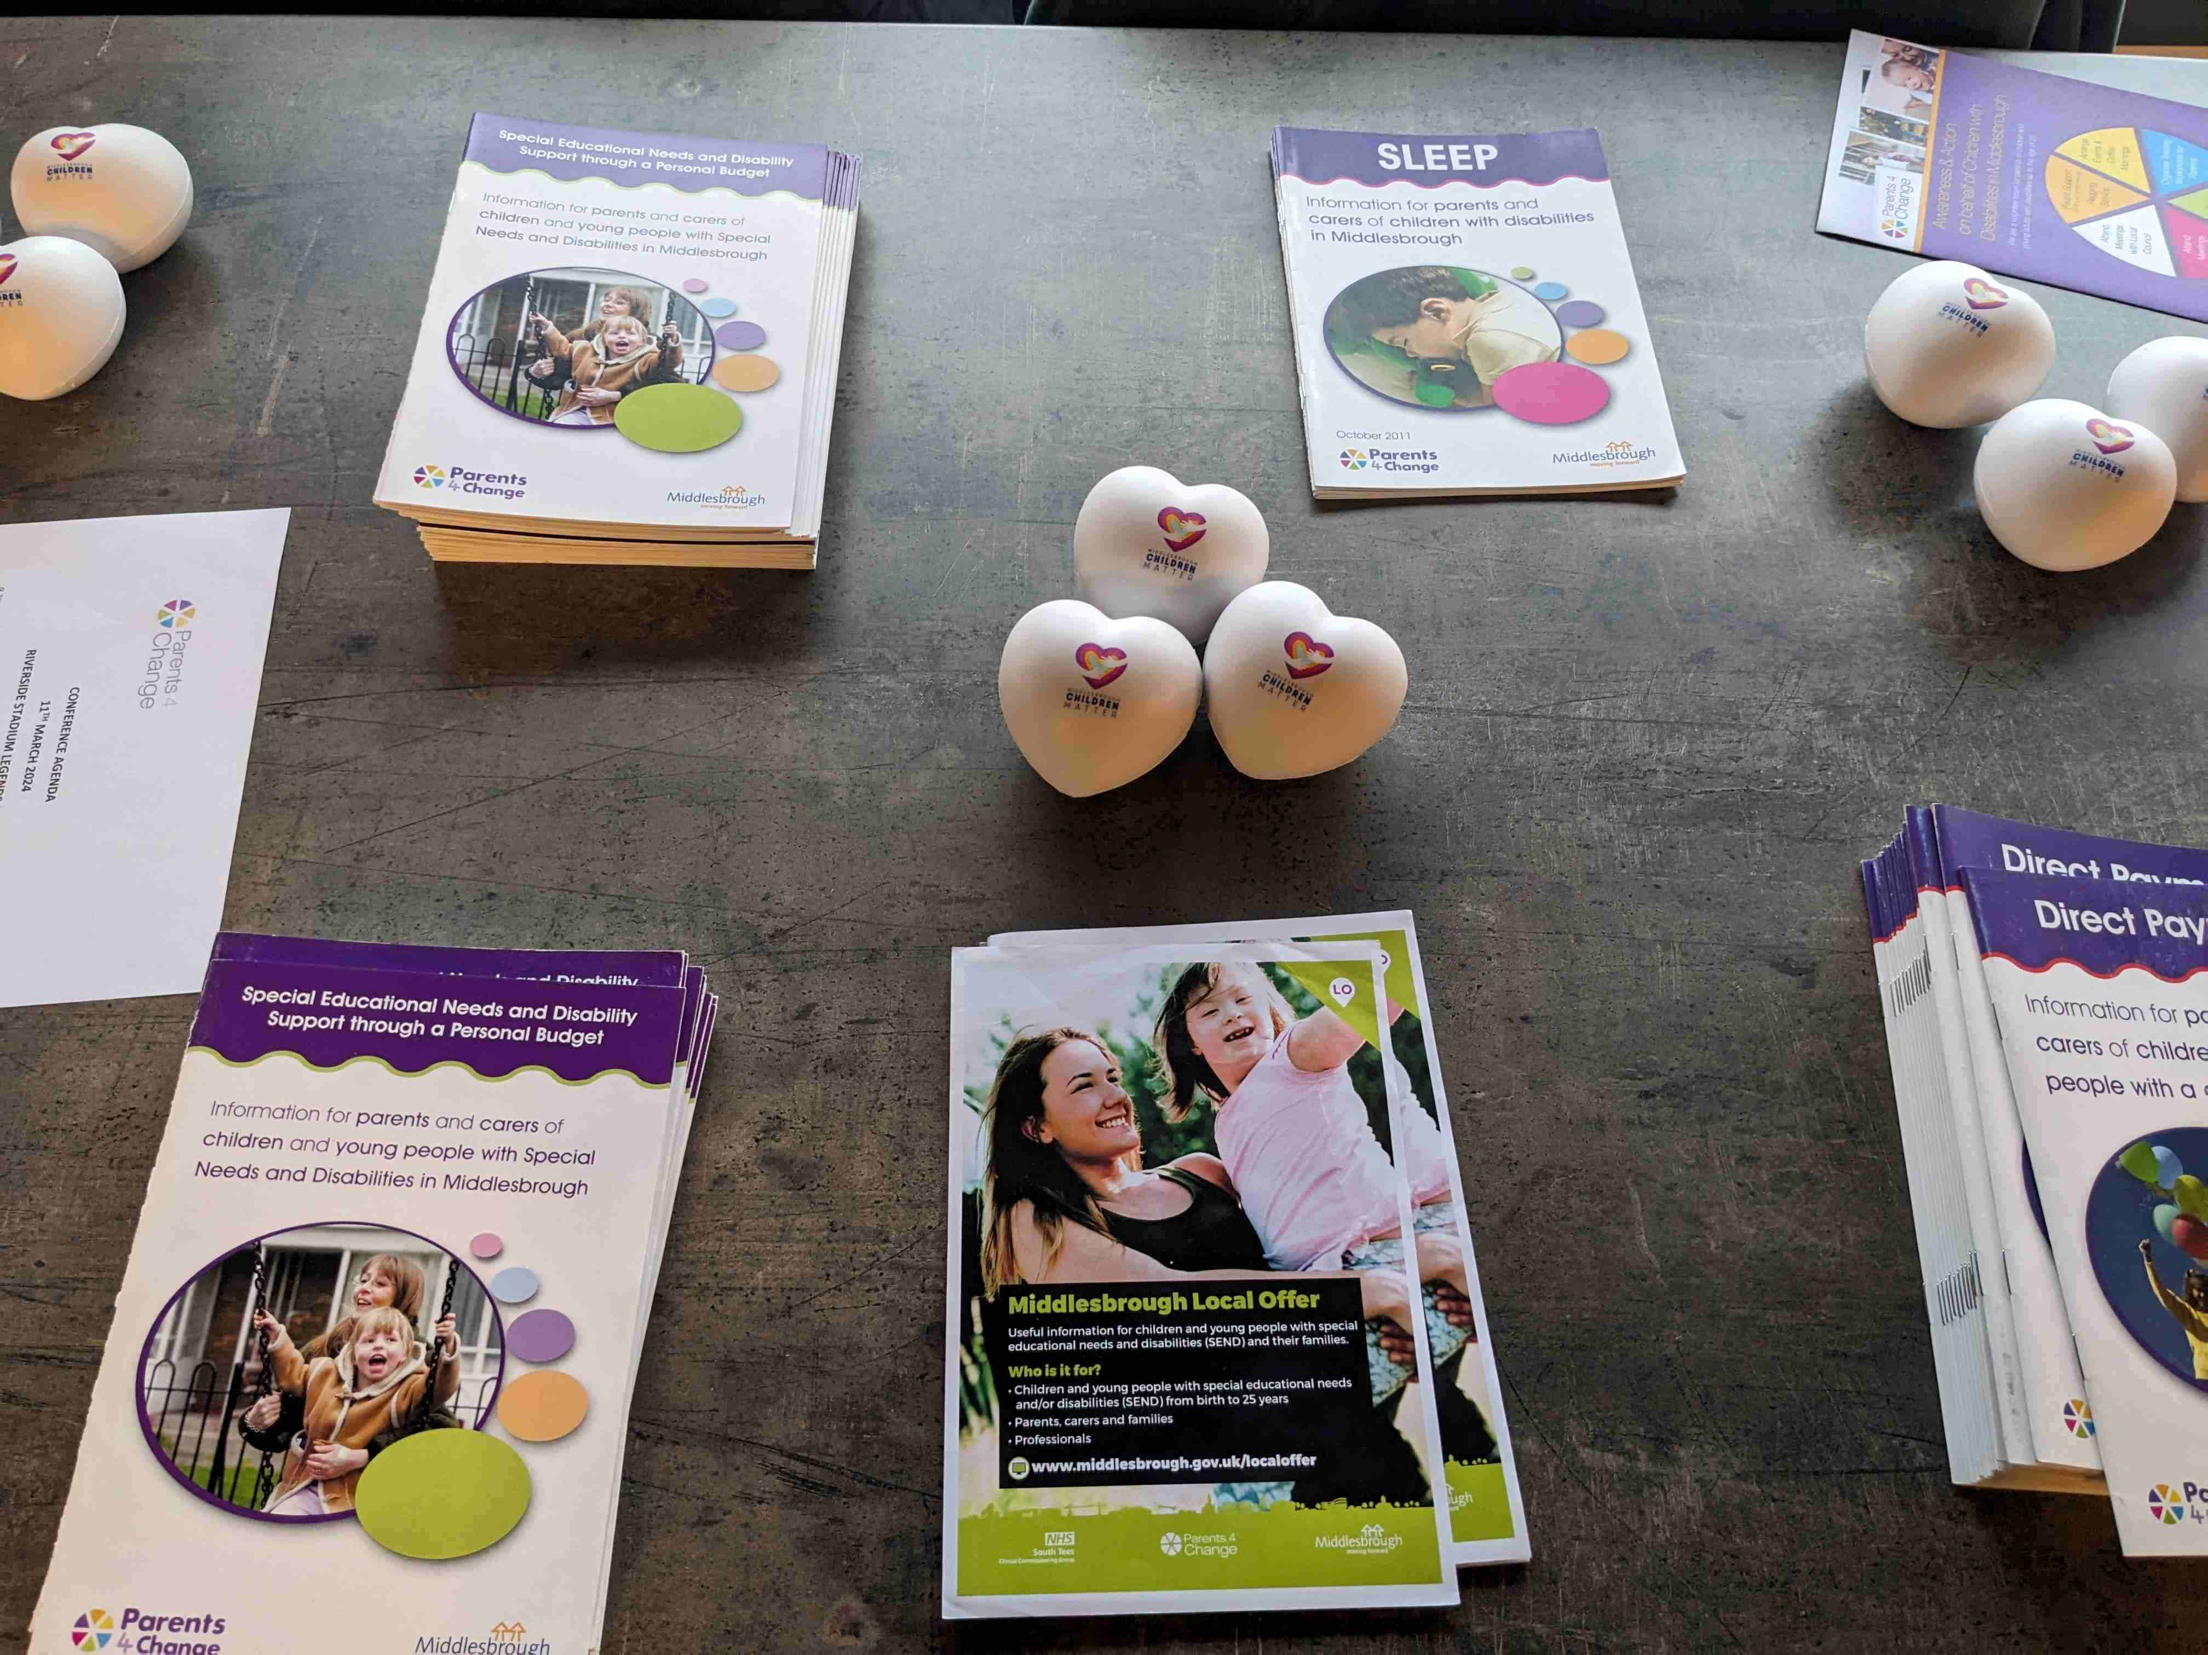

1. **Sendiass Service - Sarah Duncan**

Sarah explained the SENDIASS Team is from Barnardos and provides free, confidential and impartial information, advice and support to parents and carers of children and young people with SEND who are 0-25 years old in Middlesbrough and Redcar & Cleveland.

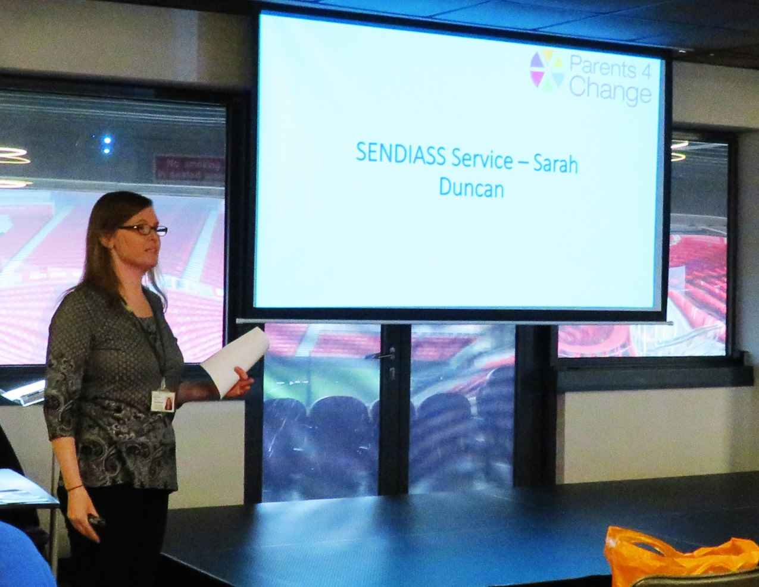

**The SEND Code of Practice 2014 states:**

“Local authorities must arrange for children with SEN or disabilities for whom they are responsible, and their parents, and young people with SEN or disabilities for whom they are responsible, to be provided with information and advice about matters relating to their SEN or disabilities, including matters relating to health and social care.”

Sarah said the service has paid staff and volunteers who can:

•help you with any problems your child might be having at school through advising you to speak to or arrange a meeting with the school SENCO about any issues

• signpost parents to other services for support and provide information about other services on our website such as health or social care

• help you to arrange a meeting with teachers and other school staff about the help your child needs in school

• help you to write down all the things you want to say at the meeting and even come along with you to make sure that you have the chance to say all the things you wanted to say

• help you, teachers and other professionals to make a plan about how to meet your child’s needs.

Sarah explained how to contact the SENDIASS service:

Email: **southteessendiass@barnardos.org.uk**

Phone: 01642 310 806

The website has lots of useful information about SEND, support services and parent user guides; [www.barnardossendiass.org.uk/south-tees-sendiass](http://www.barnardossendiass.org.uk/south-tees-sendiass)

1. **Daisy Chain - Laura Callender**

Laura explained the

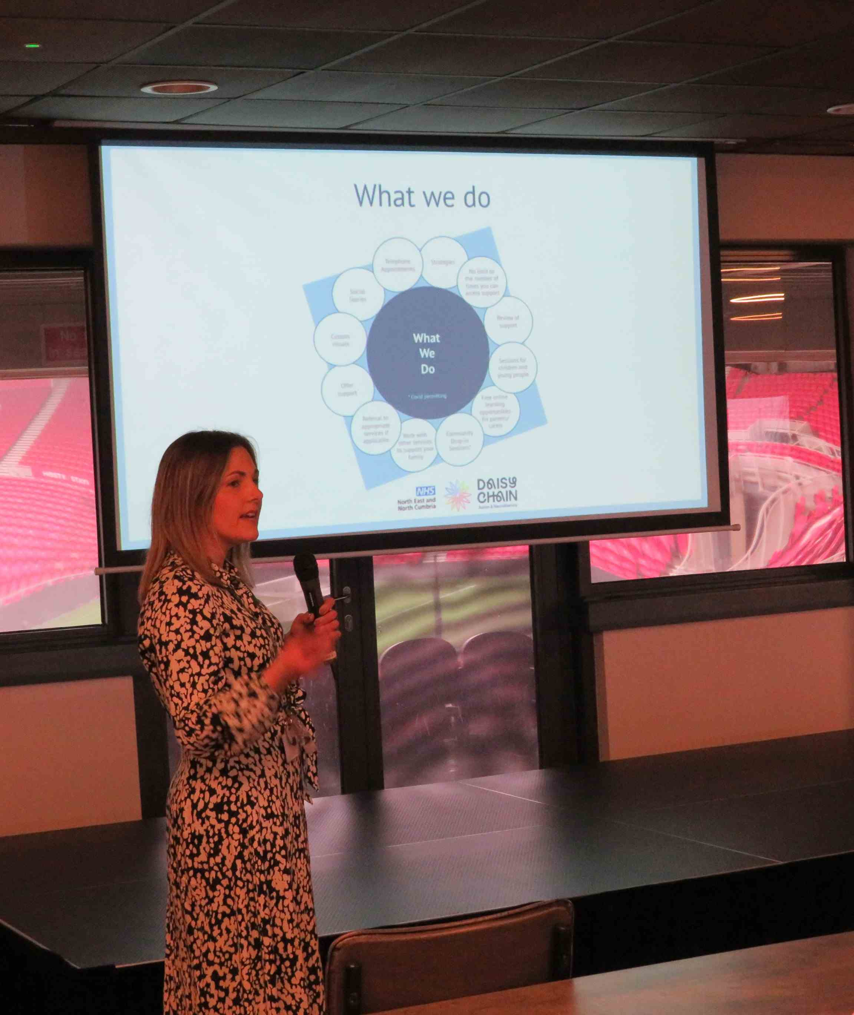

service can offer advice

and support to

anyone who has a

concern about their child.

They do not have to have

a confirmed diagnosis first.

Laura used the diagram below to explain the range of services which the service can provide which include individual appointments and training sessions on subjects such as “Sensory Support” and “Introduction to Autism”.

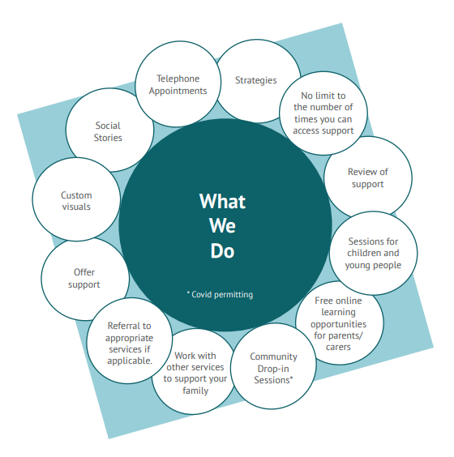

Parent and Carers can refer by emailing the team at

*family.support@daisychainproject.co.uk*

OR calling 01642 531248 (when calling please select option 1 from those available)

Laura also explained there is now a new sleep service which can be used by parents living in the Tees Valley

Children must be between 21/2 and 18 years of age and have been identified by a professional as having an additional health or development needs. Using a tiered approach the service can provide telephone support and resources, sleep workshops and bespoke 1:1 sleep assessments.

1. **Update from Adult services**

It was hoped that someone from adult services would attend at this point and talk about services available for adults/young people. Unfortunately no one was available.

1. **Closing Remarks - Ruth Johnson**

Ruth said she was greatful to everyone for attending and thanked all the speakers. She asked parents to complete a feedback form about the day (a summary is provided as an appendix to the report)

**Appendix 1 Summary of Feedback**

**Question: Did you enjoy this conference and could we have done anything in a better way?**

* Yes. Very well put together. Such a shame not a better turn out this would help so many families in the community.
* Fab conference we would like to support if we can get more parents in attendance
* Enjoyed - but maybe need parents speaking about their own experiences and about the support for them - good and bad
* Very interesting
* Learnt allot about SENDIASS and interns
* It was fantastic as always – getting all the advice and support you need.
* Was Okay
* Advertise event better- put leaflets in school rather than just being on line - ask any professional who comes to bring a parent
* Lovely venue, programme and variety of speakers
* Yes everything was good
* Conference was interesting
* Conference was very informative
* Great conference but could do with the microphone working properly
* Brilliant lots of advice
* Leaflets to SEN and schools for bigger numbers. Advertise more.
* In parts explain more (transport) Advertise more.
* It was a good venue and catering - the speakers and stalls were helpful.
* Yes it was very good – well organised with a variety of speakers

**Question: What did you learn from this conference?**

* The services are out there for support.
* Where to find co-production charter, supported internships and their fab offer
* Transport are trying to change but they could be more clear about this - and how did Middlesbrough get an Outstanding Inspection when on the ground it does not feel that way.
* Quite a lot of information
* New information about internships and DSR
* Some things I did not even know existed
* Parents seem less likely to speak out about DSR and how it works.
* Changes in Transport - and nice to meet the new Mayor.
* Code of practice suggesting 3 reviews per year - IPSEA Charity
* A lot about the different services that I did not know
* Services across the town and supported internships
* Useful information. Great info from professionals – learnt something new and friendly hosts especially Peter fromParents4Change - lovely chap
* Lots of information and support
* How to access services and what is out there.
* How to access services and what is support is actually out there.
* Internships. Very informative all round but lacking information on budgets etc.
* I can put off getting help and this event was motivational.
* I learnt more about local services and feel able to signpost parents to these

**Question: Are there any subjects you would like covering in a future conference?**

* What the local schools offer with to support with choices/preferences - bases vs special, and independent vs mainstream
* Medical issues
* All the advice is amazing and helpful
* Adult support
* Positive behaviour support - more information about what DLA could be used for.
* Services/after school clubs available for teenagers
* More about children with CP or services that deal with CP
* Special needs for older age 16+ and more help if not got EHCP. Quicker referral to acknowledge symptoms – instead of having to go down the private route.
* Budgets/short breaks/ social care provision and help and what they provide and who to. – what provision and support looks like from the local authority. Update on Report.
* An update with Chris Cooke regarding budget moving forward. Social care to update about short breaks and what the providers are and how to access. More updates and meet the CEO.
* Not sure
* Social Care Provision and support. Adult Services/Transition
* DBV in Middlesbrough how is this looking and are Middlesbrough getting involved in PINS