

Conference Report  
  
Short Breaks and Support for Families

**Friday 5th October 2018**

**Southlands Centre**

**Middlesbrough**

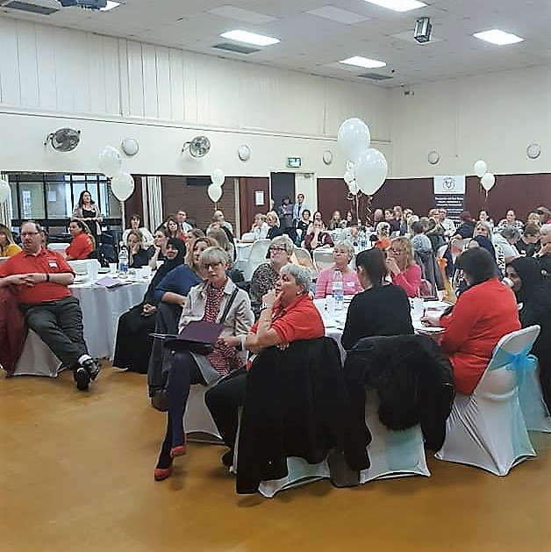

# Contents

1. Introduction - Ruth Johnson, Conference Chair
2. Middlesbrough’s Commitment to Children with Disabilities - Tony Parkinson, Chief Executive
3. Commitment to Partnership working with Families - Helen Watson, Executive Director Children’s Services
4. What is a Short Break? How do Short Breaks help Families? - Kath Mellon, Vice Chair Parents4Change
5. A Parent’s Story - Challenges and Achievements Amy Thompson
6. Support from the Davison Trust -

Jenny Dalby, Trustee

1. Support from Early Years Specialist Support Services Jenny Kitchen
2. Support through the Local Offer Jill Leck
3. Early Support for Families - Ann Lovatt
4. Support through SEND - Caroline Cannon/David Ball
5. Discussion Groups
6. Lunch
7. Beverley School Choir
8. A Parent’s Story Kath Larry
9. Questions to Panel about Short Breaks and other Support
10. Closing Remarks

**Appendix 1 Questions to the panel and responses**

**Appendix 2 Written response to additional questions**

**Appendix 3 Responses from feedback forms**

1. **Introduction - Ruth Johnson, Conference Chair**

Ruth opened the Conference and thanked everyone for attending.

She introduced the Parents4Change Steering Group and the volunteers.

Ruth provided an overview of the day and thanked a range of people for assisting Parents4Change in presenting the conference...these included Emma McHale, Caroline Cannon, David Ball and Ailisa Williams.

1. **Middlesbrough’s Commitment to Children with Disabilities - Tony Parkinson, Chief Executive**

Tony said that he has now been Middlesbrough Chief Executive for 26 months and he likes to get out and meet people. He has met Parents4Change members and is very supportive. He has helped with office space, and promoting events.

There are continued budget pressures and the Council has 25% less than it had in 2010 but is spending 47% more on Children’s Services. An extra 14% has been spent on Short Breaks.

Tony said that he cannot make any grand promises but everything possible will be done to protect front line services. Tony said that he had to make sure that money spent has the biggest impact possible and makes a difference.

Tony said he would stay until 10.30 when he had to leave for a meeting.

1. **Commitment to Partnership working with Families - Helen Watson, Executive Director Children’s Services**

Helen said that she was delighted to attend the Conference. She has been in post just over a year and it has been a tough year with an external inspection that made it clear that improvements were needed. Changes have been made and recognised and the SEND Strategy has been developed and there is an improved Health and Education Care Plan planning process.

The Early Years Specialist Support Model has also been developed based on feedback about the need to be inclusive and allow children to stay in mainstream nurseries.

Helen said that she was very grateful to Parents4Change for the work done to develop the Local Offer. Work will now need to be done to revise the Charter and the Short Break Statement. There must a focus on partnership working and a focus on the voice of the child.

Helen said she would stay until 10.30 when she had to leave for a meeting.

1. **What is a Short Break ? How do Short Breaks help Families? - Kath Mellon, Vice Chair Parents4Change**

Kath was supported by Resource Worker Lindsey Fletcher and talked about Short Breaks.

She said that Short Breaks are one of the services the Council provides to help families whose children need extra support because they have a disability. They help parents and carers have some time to themselves, or help them spend more enjoyable time with their children.

She said that this includes such things as the free trips to places like Flamingoland or South Shields and events like the Halloween disco and Family Fun days. Some people do not understand how these trips are so important, but families know that they are important because:



* they may be the only fun thing a

family does during the holidays

* they give families time to meet

each other and share experiences

* there are always staff to help if

things become difficult

* they let children who might just be

at home during the holidays meet

each other

* everyone is in the same position

so you do not feel embarrassed or judged

Kath talked about all the Short Break Services available...those provided after an assessment by a social worker and those provided via a Direct Application. She included Direct Payments, Personal Budgets, Gleneagles, Home Support, and the Fun Club.

She reminded everyone present that:

* The Council has a duty to provide short breaks - this is included in the Children and Young Persons Act 2008 and came into force on 1st April 2011.
  + The Council must publish on its website a “short break statement” which explains to families the short breaks that are available and the criteria for accessing those short breaks.
  + The Council must provide:
* Day time care in the homes of disabled children or elsewhere
* Overnight care in the homes of disabled children or elsewhere
* Educational or leisure activities for disabled children outside their homes
* Services available to assist carers in the evenings, at weekends and during the school holidays.

(The Breaks for Carers of Disabled Children Regulations 2011)

Kath said that all Councils are thinking about how they spend their money and need to be sure that they get good value for every penny spent. So it is important that all families who receive Short Break Services make it clear how essential this support is.

1. **A Parent’s Story - Challenges and Achievements Amy Thompson**

Amy talked about her life with her husband and four children. She talked about how essential the support was as her son Teddy has very complex needs. She would not be able to care for him and her other three children without support. She described how two workers come to help with Teddy, sometimes helping with physiotherapy, or helping with his breakfast, or help taking him out. This gives Amy time to care for her other children and allows Teddy to get out and about and have fun. Teddy attends Saturday Club and Fun Club run by Home Support.

Amy said that the support “helps us live our lives as a family”.

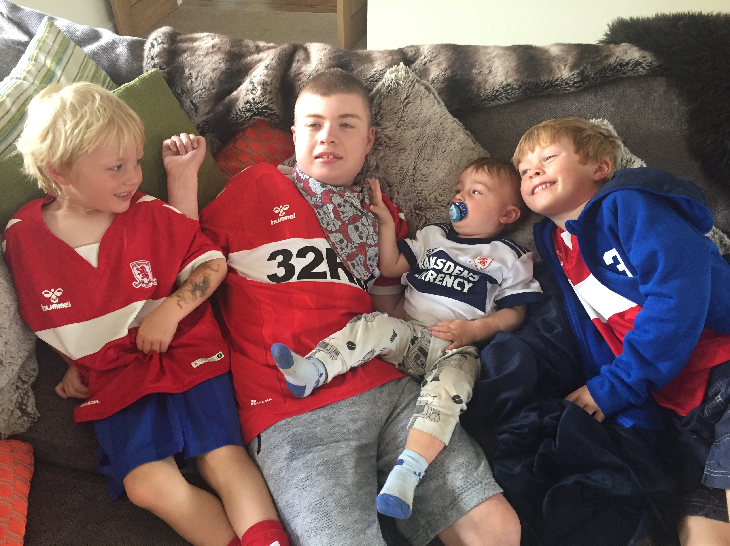

1. **Support from the Davison Trust -**

**Jenny Dalby, Trustee**

Jenny talked about the charity which provides small grants to children and young people living in Middlesbrough who are sick, or who are recovering from an illness or who have a disability. Application forms are very easy to complete and the charity can give small grants. Examples agreed recently include:

* Contribution to a family weekend away where a family would not otherwise have a holiday
* Help with moving costs where a family have had to move to a specially adapted house
* Help with buying a tumble dryer for a family caring for a sick child
* Help towards buying a special car seat
* Help buying special sensory toys

Copies of application forms were provided in the room and can be obtained from the Children with Disabilities Social Work Team at Viewley or from:

The Davison Trust

PO Box 519

MIDDLESBROUGH

TS1 9GS



1. **Support from Early Years**

**Specialist Support Services**

**Jenny Kitchen**

Jenny talked about the restructure of the Cleveland Unit Child Development Centre and the Inclusion Support Team to create the Early Years Specialist Support Service. She stressed how important it was to make sure that this was as good as specialist provision so parents have a real choice.

Not so many specialist places are now provided as they are not needed as the additional support is put into inclusive Early Years Services.

The new service has 37 staff in total

* Head of Service (Specialist Teacher)
* 2 Senior Specialist Teachers
* 3 (1.4 FTE) Specialist Teachers
* 3 HLTAs
* 1 O&I Co-ordinator
* 2 SEN Support Outreach Workers
* 17 SEN Support Practitioners
* 6 additional part-time support staff
* 2 Admin

The new service provides support to over 100 children in 27 different settings.

Support provided includes:

* Multi-disciplinary assessments
* Assessment visits and Outreach Support to Early Years Settings

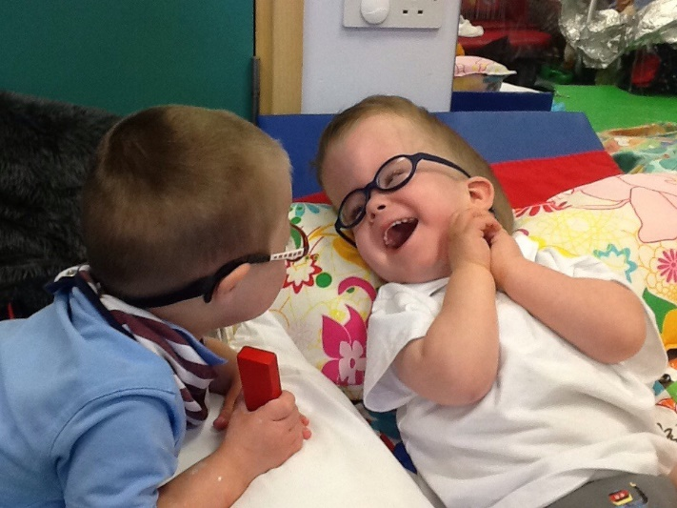

* Portage
* Assessment Nursery
* Training for Early Years

Practitioners.

Plans for the year ahead include:

* Launching an Area SENCO role
* Launching an Early Years SEND Training Course
* Developing ‘SEND Champions’ in other Early Years Settings
* Designing a new logo and information leaflets

1. **Support through the Local Offer Jill Leck**

Jill asked who in the room had heard about the Local Offer. There were very few responses.

Jill asked who had used the Local Offer. There was no response.

Jill explained that the Local Offer is a website which provides information on localservices and support on

offer to families including children and young people (aged 0 - 25 years) with special educational needs or disabilities.

There is information about:

* Education and training
* Early years and childcare
* Health and wellbeing



* Leisure activities
* Transport
* Social care
* Support services
* Money and benefits
* Becoming an adult

Jill said that she needs people to look at the website and provide feedback. She wants to know how the website can be improved and what additional information people would like to see. She asked people to think about joining the email consultation group

[GetInvolvedLocalOffer@Middlesbrough.gov.uk](mailto:GetInvolvedLocalOffer@Middlesbrough.gov.uk)



1. **Early Support for Families - Ann Lovatt**

Ann stepped in to provide a presentation on behalf of Gail Earl from the Stronger Families Service.

The service provides Early Help support for children, families and young people. Early Help is about working with families as soon as a problem emerges in order to prevent any problems from getting worse. There are four teams within the Service.

* The Family Partnership Team provides information, advice and guidance to families and services and helps them to work together.
* The Family Case Work Team works with families who require additional help due to a range of issues such as domestic violence, parental mental health and substance misuse. Families are allocated a Lead Practitioner from within the team.
* The School Readiness Team works from eight Children Centres in Middlesbrough to help children become ready for nursery and school
* The Work Readiness Team is responsible for tracking and following up destinations of all young people aged 16-18 years, and up to 25 years if they have special educational needs or are a care leaver.

1. **Support through SEND - Caroline Cannon/David Ball**

Caroline and David talked about Special Educational Needs and Disability and some of the developments which have happened over the last year.

Caroline talked about the Special Educational Needs and Disability Strategy 2018-20. The strategy is:

* To further develop **strategic leadership** across Education, Health and Social Care
* To ensure **greater involvement of children, young people and families** around discussion and decision making about the services and support they need
* To further develop the **Local Offer**
* Greater use of **data** to drive improvement in provision and outcomes for children and young people
* To **jointly commission** services across Education, Health and Social Care

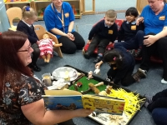

David said that work has been undertaken to make the Education Health and Care Plan process clearer and reduce some of the paperwork.

David talked about how pleased he was that Educational Psychologists have now been recruited. There had been a period of time when there were none in post so it is good that progress has been made.

He also talked about High Needs Funding. This is the additional funding which can be used to support children and young people with additional needs. In some authorities this is only available for children with an EHCP in place. This is not the case in Middlesbrough and this funding can be accessed for children without an EHCP when it is needed.

David said that the next steps would be to implement the SEND Strategy and to make sure that more people in the local area understood the process.



David told everyone that he would be in the room all day and he was happy for people to approach him to discuss any issues.

1. **Discussion Groups**

At this point everyone in the room took part in table discussions to agree which questions would be put to a Panel of professionals after lunch.

Each table was asked to agree two questions. One about Short Breaks, and one about either Health, Education or other services.



1. **Lunch**

Everyone enjoyed lunch at this point.

It was agreed that a very good lunch had been provided by Parents4Change.

1. **Beverley School Choir**

After lunch music was provided by Beverley School Choir. Everybody enjoyed a very spirited performance from the young people who sang a range of songs including Rule the World, You Raise Me Up, and This is Me.



1. **A Parent’s Story Kath Larry**

Kath talked about how important Short Breaks are to her and her family. She said that she has a son Owen who is 10 and a daughter Emily who is 20. She said that there was a time when Emily just used to sit in her room and see only her mother. It was difficult to find time to be with her but also to care for Owen who enjoyed interacting with people.

Now life is very different. The children have support and funding in place and can go to the cinema, go bowling and enjoy the trips. A carer takes Owen out once a week. Kath said that the support has meant that as a single carer she is now able to spend one to one time with each child.

Kath said that the service had helped her family so much and had been “an absolute godsend”. Kath said that thanks to the service “our lives are just fantastic now.”



1. **Questions to Panel about Short Breaks and other Support**

At this point in the Conference the questions which had been agreed during the morning table sessions were put to a Panel of Professionals.

Twenty questions were discussed. More had been asked but there was not time to discuss all of them.

**These 20 questions and the answers are provided in Appendix 1**

**A written response to some of the additional questions was provided by Michelle Underwood and is included in Appendix 2**

1. **Closing Remarks**

Kath Mellon thanked everyone for attending the Conference. She asked people to complete a brief survey about the conference.

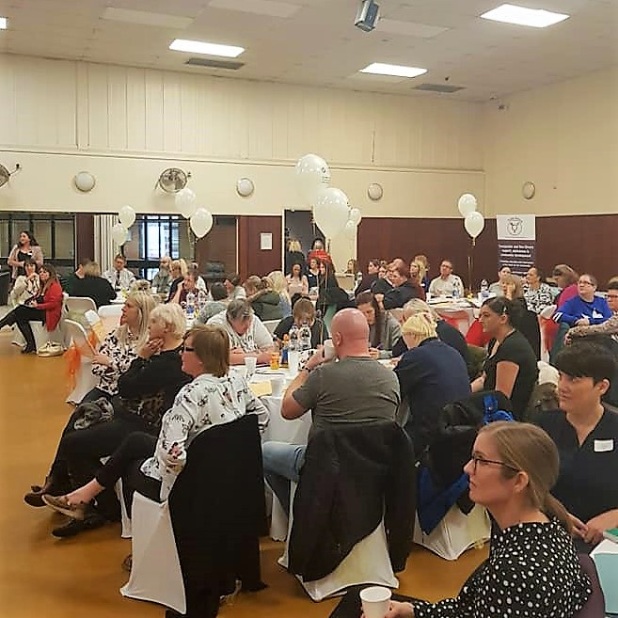

**A summary of the responses to the survey are provided in Appendix 3**

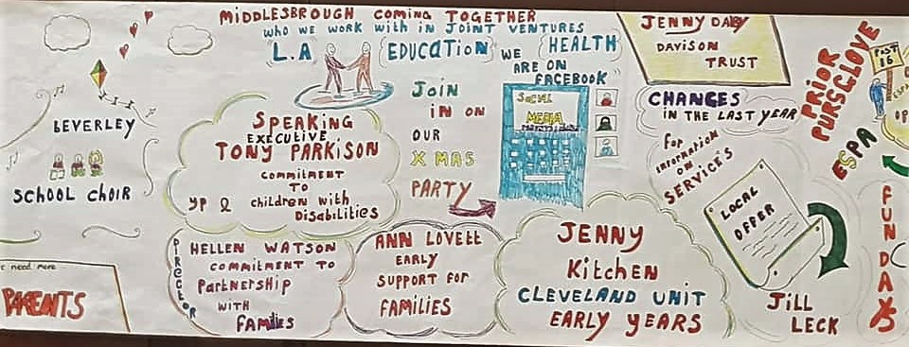

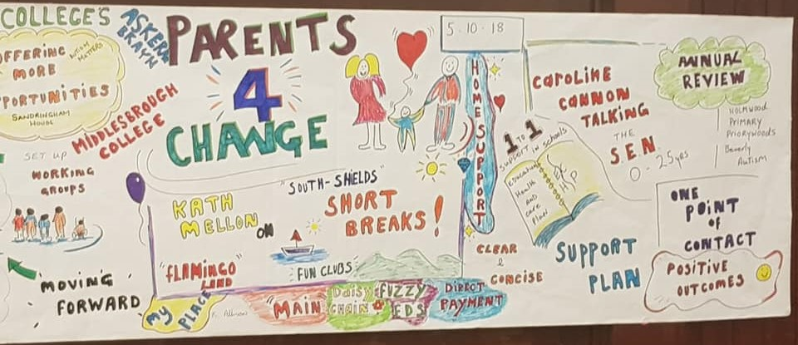

(A pictorial description of the day produced by Parents4Change)

**Appendix One - Questions to the Panel and responses**

**Members off the Panel**

* **Rod Morris CAMHS**
* **Debbie Smith Transitions Team Manager MBC**
* **Caroline Cannon Head of SEN and Vulnerable Learners MBC**
* **Melanie Jones Commissioning MBC**
* **David Ball SEN Manager MBC**
* **Ian Walker Social Work Manager MBC**
* **Louise Walker Short Break Facilitator MBC**
* **Jill Leck SEND Officer MBC**

**Questions to the Panel and Responses**

1. **What support from CAMHS can be provided to families following a diagnosis of autism? Where is the support previously provided by Early Bird?**

Response was provided by Rod Morris who said that although there is no post diagnosis service from CAMHS they do signpost to organisations such as Daisy Chain and MAIN who can support families. Unfortunately the Early Bird sessions have ceased due to staff resource. If there are conditions such as anxiety or depression the child will be seen.

1. **Why are waiting times so long for CAMHS?**

Response was provided by Rod Morris who said that referrals are seen within 4 weeks..often 3 weeks. But sometimes there are capacity issues and people have to wait longer. It takes 6 months to diagnose ASD.

1. **Have all providers of short break support put their names on the new framework?**

Response was provided by Melanie Jones who said that they had not.. The information went out in July but few responded. The information is going out again.

1. **Is there a limit to the number of short break applications a family can make?**

Response was provided by Louise Walker and Ian Walker who said that a Direct Application was usually made annually but could be amended if there was a change in circumstance. Children who had a social work assessment could be reconsidered if circumstances changed.

1. **How does a child move to adulthood without an EHCP?**

Response was provided by David Ball who said that an EHCP can continue until a child is 25. There is no unwritten agenda to cease plans as long as the child is engaged and progress is being made. Anyone concerned could contact the SEN duty officer on 01642 201831 between 8.30 and 4.30 for discussion. David said that there is careful planning for each child and a Transitions Forum is part of the planning process.

1. **What information/guidance/support can be provided to the wider family when the young person will not engage?**

Response was provided by Debbie Smith who said that some young people do tell us to “get lost” but workers do their best to build up trust and a duty worker in the Transitions Team can provide advice to families.

Rod Morris also responded and said that engagement with CAMHS was often not easy. CAMHS would explore why a young person was not engaging. They would keep trying and would need a good reason to discharge. CAMHS would work indirectly with parents or surrogate parents. CAMHS would signpost to other services depending on the needs of the Child or Young Person.

1. **What is available from the Local Offer for children and young people experiencing mental health issues?**

Response was provided by Jill Leck who said that there is a section on Health and Wellbeing and a section on Support Services. Details concerning many services are available and MIND will also soon be included.

1. **How can the criteria for adult services be made clearer?**

Response was provided by Debbie Smith who said that she thought it would be useful to put the criteria on the website.

1. **Would you consider offering a computer games event for autistic children who might not enjoy outings without parents?**

Response was provided by Louise Walker and Ian Walker who said that that this would be considered “Watch this Space”.

1. **Can there be increased publicity about Short Breaks?**

Response was provided by Louise Walker and Ian Walker who said that they were already publicising Short Breaks in many ways but were open to suggestions...please contact Louise or Ian with ideas.

1. **Can you explain the guidelines for moving from mainstream to specialist school?**

Response was provided by David Ball who said that an EHCP was needed and this was a 20 week process but occasionally a child would be moved to a special school earlier than this where it was felt that this would aid the assessment process. When addressing the suggestion that sometimes children are placed in a special school because this is cheaper than providing 1:1 support in mainstream he said that it would be wrong to say that cost is not sometimes part of the decision, but sometimes support is easier in a specialist setting. Parents do have the right to challenge decision making and take the Council to Tribunal. David noted that the number of SEN Tribunals is very low in this authority.

1. **Can you simplify the EHCP process?**

Response was provided by David Ball who said that they were always trying to make it simpler and that they were working on a simple diagram which he hoped would help.

1. **Who funds sensory processing disorders assessments?**

Response was provided by Rod Morris who said that he wanted to make sure that he provided a full response and would find out before he provided this information.

After the conference a response to this question was provided by Michelle Underwood from the North of England Commissioning Support Unit which explained that a family cannot apply themselves for funding for a sensory assessment. A GP or Consultant within secondary care can submit an Individual Funding Request (known as an IFR). The request would need supporting evidence. The request is submitted electronically using an online system so cannot be submitted by anyone without access to this system.

Michelle said that if the request met the necessary criteria it would come to the Clinical Commissioning Group Individual Fund Request Panel (CCG IFR Panel) for discussion/approval.

1. **Is there a budget for the Short Breaks Grants programme?**

Response was provided by Melanie Jones who said that that there was this year.

1. **Can we have more Short Breaks?**

Response was provided by Ian Walker who said that it would depend on why they were wanted and what outcomes were going to be achieved. The support to families can increase or decrease as the needs of the child change. However families need to consider statements previously made about the budget. There has been no huge cash injection.

1. **How can Academies be supported to help families?**

Response was provided by David Ball who said that there were some really good academies but there was some varying practice. He said everyone needed to work together and support and challenge each other. A new liaison group has been set up to help people work together.

David referred to close working between Academies and CAMHS and at this point Rod Morris referred to a drop-in session arranged recently and how disappointing it had been that families had not attended as professionals had spent a morning making themselves available to families... a number of parents present in the room said that people had not attended as the event had not been well publicised. They would have attended if they had known it was taking place.

1. **Can transport be agreed for Short Breaks when parents do not drive?**

Response was provided by Ian Walker who said that transport could be provided ..it would depend upon the circumstances.

1. **Do children who are “Looked After” in foster care or adopted qualify for Short Breaks?**

Response was provided by Ian Walker who said that they did.. the only difference was that some children in foster care might not be able to access a Direct Payment... other Short Break Services should be available if they were needed by the child.

1. **Can a parent obtain a breakdown of what the school spends its “high needs” funding on?**

Response was provided by David Ball who said that the school should be able to make that information available.

1. **If an EHCP has been declined how does the school evidence the support they are providing is not meeting the child’s needs?**

Response was provided by David Ball who said that the school and parents need to be able to provide evidence that the strategies tried have not been effective and ask for the EHCP to be considered.

**Appendix Two - Written response to additional questions**

**A) What is being put in place by health to support families?**

CAMHS- provides a comprehensive approach to referred young people and families, including assessment, formulation and intervention which has been designed collaboratively, tailored to need of the child, young person and their families.

OT/Physio - we offer support generally in our sessions to families, sometimes we act as an advisory, link to other professionals etc. We do occasionally run info sessions for families. OT have done this more recently. Physios have done this in the past around increasing knowledge for parents/ carers about conditions etc.

**B) Is there a therapy package available for children with Sensory Processing Disorders/Difficulties?**

OT/Physio - Sensory processing disorders/difficulties is not a recognised condition in the UK, our OTs will assess any child that is referred with an occupational performance difficulty whatever the reason for this, they will then offer a suitable package of intervention, that may include recommendations, home or school visit, therapy intervention or any combination of these. Referrals won’t be accepted for sensory difficulties if there aren’t any occupational performance difficulties such as activities of daily living: self care, productivity -school based activities, play and leisure.​

**C) Can the timing of support sessions be looked at (Health) 6pm on an evening is not acceptable.**

CAMHS- At the moment Middlesbrough CAMHS is 8-6pm Monday, Wednesday, Thursday and Friday-Tuesdays it is 8-8pm.

OT/Physio - we work 8:30- 17:00

SALT - Appointments are offered between 9-5 other than specific arrangements with particular families (eg where school hours start at 8.20 then 8.30 appointments have been offered in school).

**D) Why is medication taken away? Is this because it costs too much?**

CAMHS -Medication is never “taken away” in CAMHS-it may be reduced or stopped but only if clinically indicated to do so and prescriber has consent from young person/family to do so.

**E) SALT. Why is there such a high turnover of staff?**

Staff retention in our department is actually quite high, there is very little staff turnover. However, we do make changes to staffing allocation to teams where we may need staff with particular skills or where there are issues with staff absence. As a largely female department of relatively young women we do have fairly regular maternity leaves which results in us moving staff around our teams to ensure equitable service. We try very hard to ensure every team has the right number of staff for the size and complexity of the caseload within the staff resources that we have. We have had several retirements recently which has resulted in newly qualified staff being recruited and therefore some movement of staff around the department. We also still have several vacancies which again means we have had to move staff around to provide a fair and equitable service across the South Tees patch. We sometimes experience an increase in referrals for a particular team – we try to be responsive to this by moving staff around in order to avoid increasing waiting times. We also try to ensure that the therapist involved is the most skilled and experienced for the particular communication difficulty. So, staff may change but only to provide the most appropriate therapy.

**F) Why is there sometimes no health representative at EHCP meetings?**

CAMHS has an identified person –Debbie Mearman-previously Jude Rose-to attend EHCP meetings

OT/Physio - Staff attend EHCP meetings if there are complex issues to raise/ support families but due to time constraints this isnt the usual practice. A report is always completed. If therapy staff were to attend all EHCP meetings ( including RPM,SAM's Initial and review meetings) this would drastically reduce the amount of time they would be able to spend face to face with children and young people.

SALT - We do try to attend EHCP meetings where a child has specific and severe communication difficulties but unfortunately we cannot attend all of them as we do not have sufficient resource to attend all meetings and provide therapy contact too. We try to prioritise where we feel our attendance will be of specific support to the family and would encourage families to discuss this with us if they wished us to attend. We always provide detailed written information and targets for the EHCP and would always encourage families to contact us to discuss anything they wish to.

**G) How can better support be provided to young people with mental health issues but who receive a late diagnosis?**

They will get same CAMHS input as anyone with an early diagnosis-tailored to need of young person/family following assessment of need and judgement made about risk, there is no blanket approach. All referred youngsters are adjudged on merit and identified pathology from assessment activity determines what comes next.



Appendix 3 2018 CONFERENCE

SOME OF THE RESPONSES FROM FEEDBACK FORMS

SUBJECT Short Breaks

This is what I would like to say about short break services.. including trips and outings, Gleneagles, Home Support, and Direct Payments.

Responses

* **We have only this year found out about Parents4Change and also Short Breaks. We happily have used them including party/disco South Shields and Flamingoland**
* **Short breaks helped my son with his social needs. Although he only did it for a year it was a success.**
* **My son enjoys days out on a Saturday with Home Support and also the clubs during the holidays.**
* **The easy process to apply for Short Breaks makes a lot of difference.**
* **My family enjoy the Flamingoland Trip very much**
* **Trips are fantastic…we can spend the money towards trips for our son.**
* **I did not know anything about it but today I have asked how to apply.**
* **I had little information about this support until today.**
* **I do not have any as no disability diagnosed…only difficulty**
* **This is the first time I have heard of this…thank you for the awareness**
* **I think this service will be of great value**
* **My family could not manage without. I am a single parent with two challenging children so we can be isolated at home. Now my older daughter can do safe and fun activities and I can give her sister attention and do fun activities with her.**
* **Have not used short breaks but they sound wonderful for those who need them.**

SUBJECT Other Services

This is what I would like to say about other services …including Early Support, Early Help, the Davison Trust, SEND and the Local Offer.

Responses

* We have used the Davison Trust which helped towards a family holiday earlier this year.
* We have not used them. We do not know enough about them.
* I was not aware of all these services and the ones that apply to me I will now look further into.
* The Davison trust was an easy process and allowed us to afford to create a safe space outdoors for my grandchild to be able to access independently.
* Excellent service we have received so far
* I was very happy last year with the help for my son.
* Staff needed more training in understanding autistic traits in girls as I searched for years for advice/support in understanding why my daughter is different. She is now 13 and only just on pathway in CAMHS after three refusals as other professionals don not see what goes on at home. I was just made to do numerous parenting courses.
* Thank you for making me aware of what is available for my daughter.
* Found the information from Jennie Kitchen extremely helpful. The information on SEND and EHCP was also helpful.
* I wish they were better **publicised** and more people made aware of them.
* Good experiences are facilitated by good relationships with school, GP etc.

SUBJECT The Conference

This is what I would like to say about the Conference

Responses

* Good food
* Information from the speakers would have been appreciated rather than the quick slide show.
* Really enjoyed today. Need more information for transition needs when turning to adults.
* Glad I came. Better than I expected But so much more information I would like to be given.
* It was useful with all the information that was given.
* The conference I have found to be very informative. I have discovered lots of services that I was previously unaware of.
* Very informative I now have a better understanding of short breaks and EHCP.
* Excellent. Excellent. Really enjoyed meeting parents and other health care professionals.
* I am happy and say thank you for help for families who have special needs children.
* First time attending. Very helpful and informative. Look forward to receiving more information. Was very focused on autism and not much else.
* Gave me a lot of information. I feel I am better armed to challenge school that my daughter needs more even though they do not see any autistic traits.
* Conference really helpful for parents/carers and professionals very useful.
* Very informal. Got loads from it.
* The day was very informative. I have found out more today than the last six months.
* I really enjoyed it. There was some useful information and it was good to speak to other parents.
* Excellent conference. Well organized so that parents of similar aged children/similar diagnosis were seated together. Nice lunch. Useful to have members of council teams present and actively involved..David ball, Ian Walker etc. Thank you.